Request Course Access – Email Template

Instructions
If you need to ask a UW professor, departmental advisor, or program coordinator for permission to enroll, be sure to give them the information they need as well as a recent copy of your university transcript to make a decision regarding your enrollment.
Below is an email template to fill out and send. Information in brackets [like this] indicates where you need to fill in your own information. You can find the professor, departmental advisor, or program coordinator information under the ‘subject note’ when you search for the course in UW Course Search & Enroll.
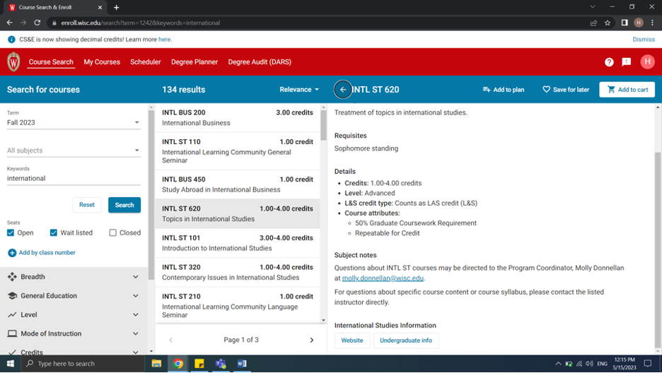

Email Template
Professor [Professor’s Family Name],
My name is [Your Name] (campus ID# ____________) and I will be attending UW–Madison next semester as an exchange student through the Wisconsin School of Business (WSB). I am currently a [3rd year, 4th year, graduate, etc.] student at [Home University] studying [your major/degree]. I am interested in taking your [name of class - example: Math XXX] class next semester.
[List the LEC #, DIS #, and LAB # as applicable for the course].
The class number for the section I am interested in is [5 digit Class No. found in the Course Guide/Course Search & Enroll].
Because I am a non-degree student, I received an error message when I tried to enroll for this course. At [Home University], I have taken the following courses that I feel have prepared me to take a course like yours:
[include list of relevant course titles taken at your home university and attach a recent copy of your transcripts].
May I have your permission to enroll in your class? If so, a permission in SIS will need to be entered by your department to allow me to enroll. If you have any questions about my student status, please feel free to contact my advisors at Global Programs at WSB at incoming.exchange@wsb.wisc.edu . Thank you for your assistance. I hope to hear from you soon.
Sincerely,
[Your Name]

